Name: Truong Dang Truc Lam  
ID: B2111933   
Class: CT209H-M04

**LAB 5**

**File Services**

**EXERCISE 3: SHARING A FOLDER**

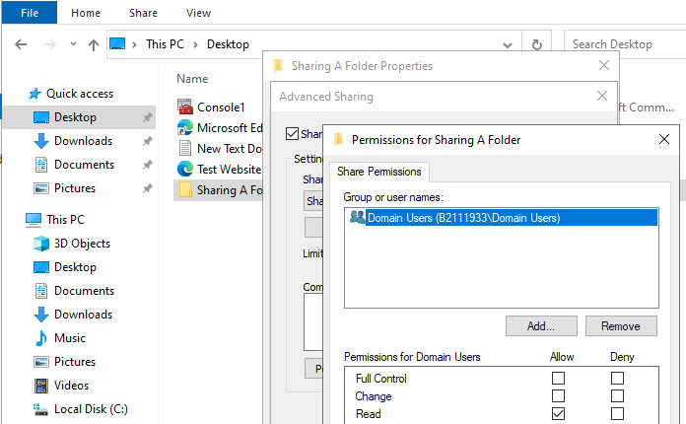

Sharing a folder

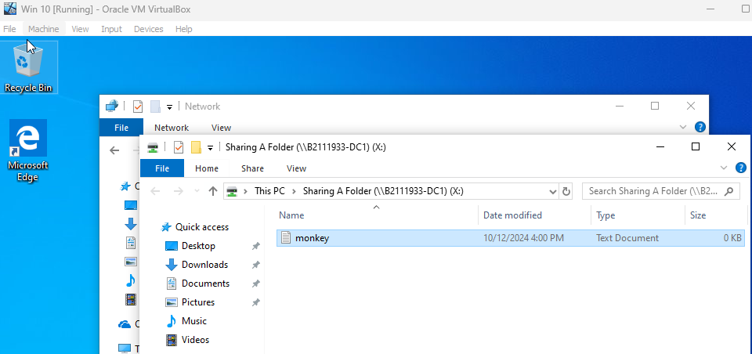

Connect from client and create a file

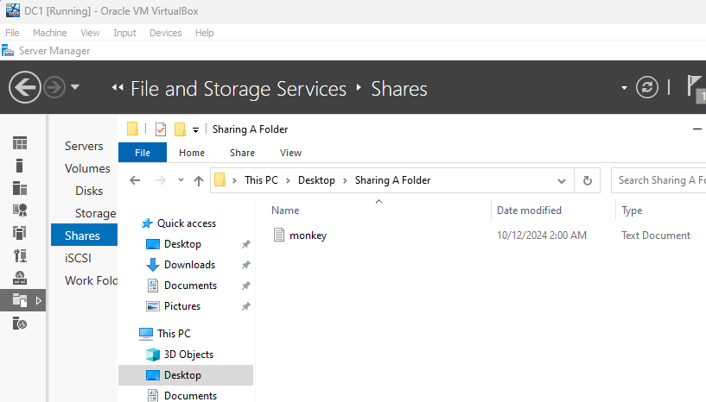

Check the result from DC1

**EXERCISE 4: CREATING SHARES WITH SERVER MANAGER**

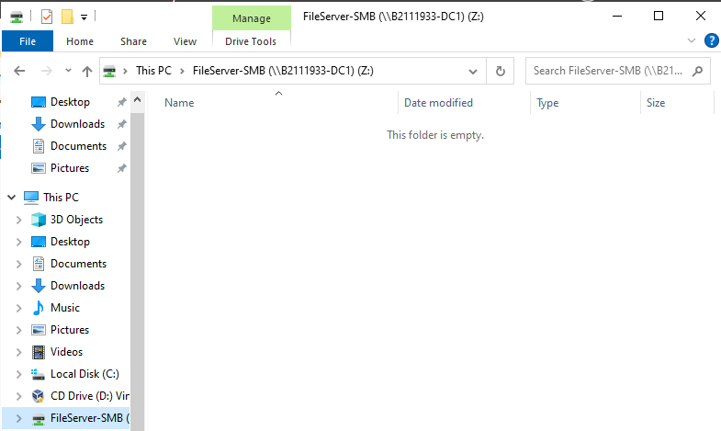

Create a new Share

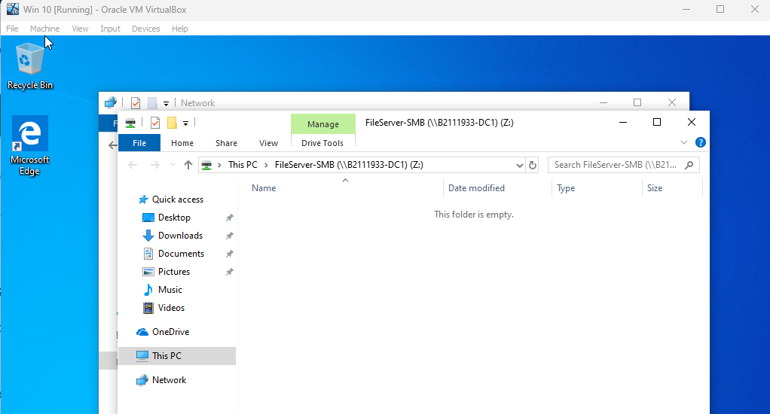

Connect to the Share

**EXERCISE 5: ENABLING DISTRIBUTED FILE SYSTEM AND CREATING A**

**NAMESPACE**

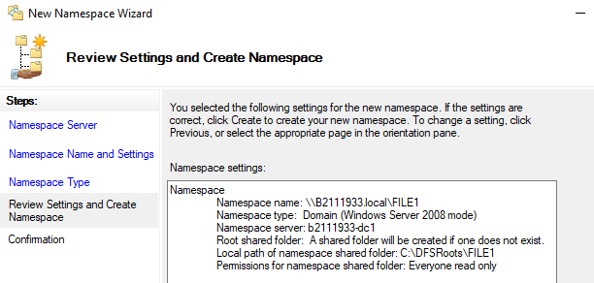

Create a Namespace

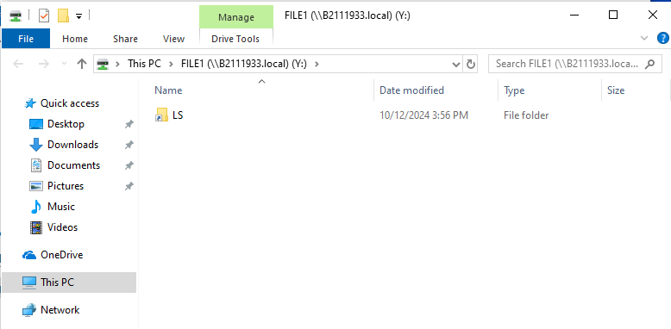

Connect to the Namespace

**EXERCISE 6: CONFIGURING DISTRIBUTED FILE SYSTEM REPLICATION**

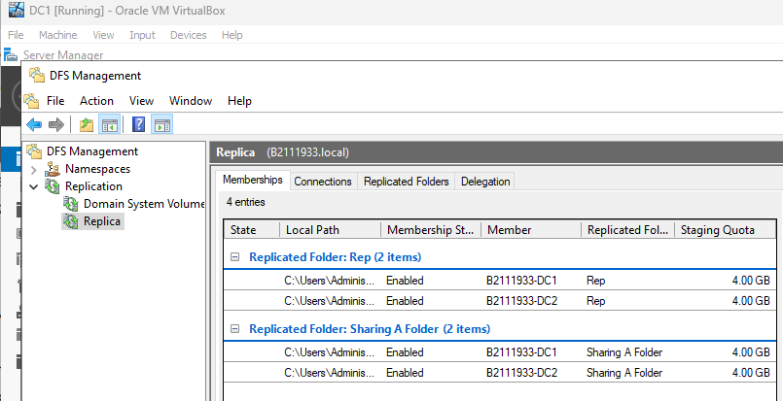

A file system replication

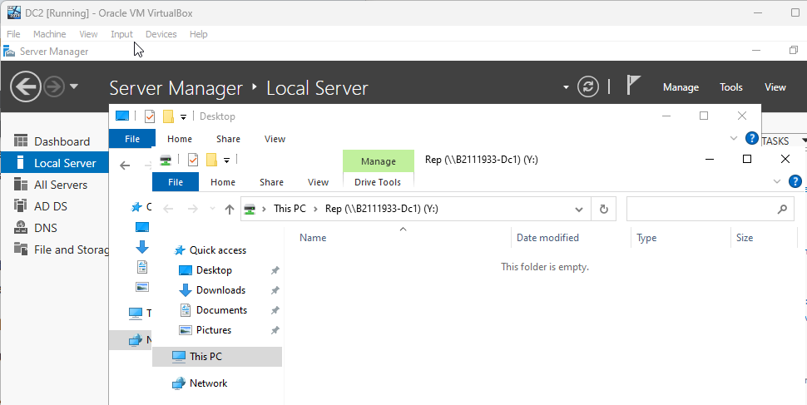

Connect to a file system replication

**EXERCISE 7: CREATING AN ISCSI TARGET ON YOUR SERVER**

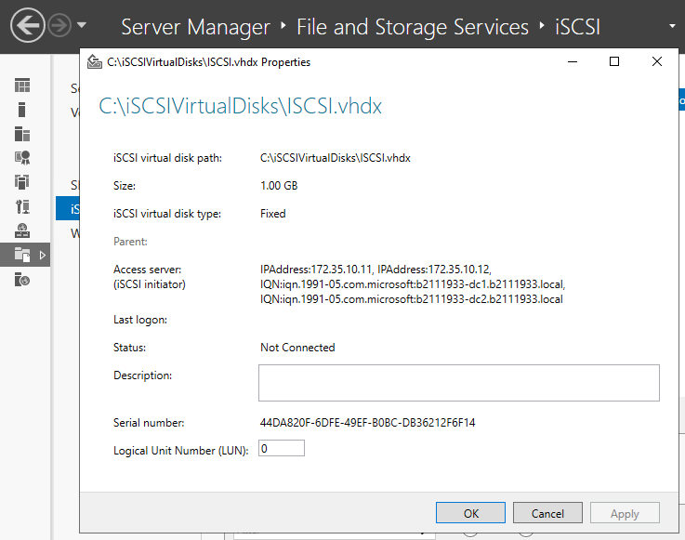

Create an ISCSI target

**EXERCISE 8: CONFIGURING AN ISCSI INITIATOR CONNECTION**

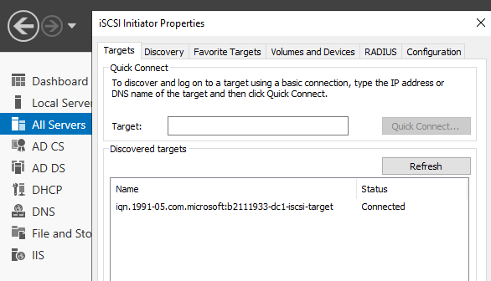

Configure an ISCSI initiator connection

**EXERCISE 9: SETTING UP WINDOWS SERVER 2019 WORK FOLDERS**

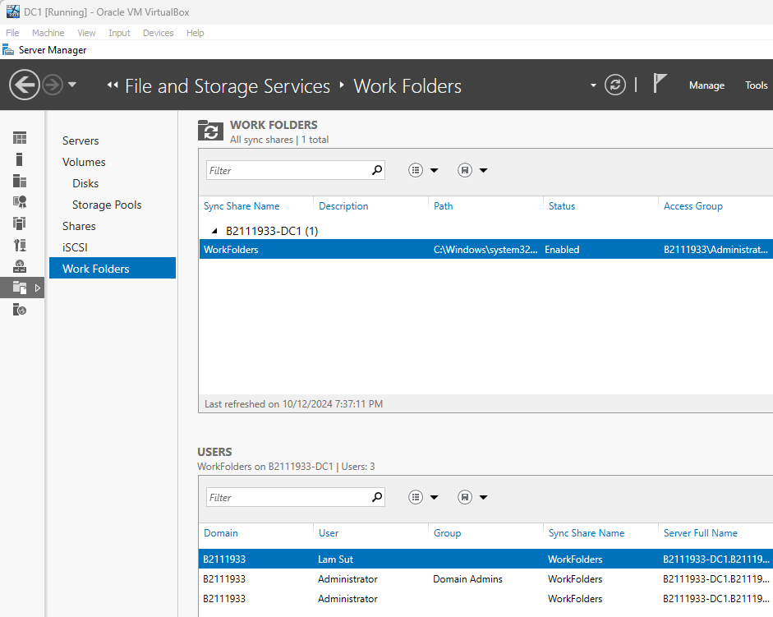

Create Work Folders server